Milestone5 was not as simple as I thought. I assumed since we had the data collected from different data sources and consolidating them and presenting it with visualizations would be easy. It was not bad and I had a lot of learning.

My project is about the breweries in the US. Looked for the population in that city, the demography around the zip code, and the count of breweries. I was able to see a pattern based on the data interpretation.

Below are the three datasets:

1. API - <https://api.openbrewerydb.org/breweries>
2. Website - <https://en.wikipedia.org/wiki/List_of_United_States_cities_by_population>
3. CSV file - <https://www.kaggle.com/chengjhj/zipcensusdemographics>

I decided to download the data from Milestone 2, Milestone 3, and Milestone 4 into CSVs. The CSVs were read in Milestone5 to convert them to Dataframes. Using SQLite loaded all three data frames into the database. Then merged the three queries using joins. The results are then directed to a data frame.

The data frame was used for the visualizations. I tried to use different kinds of visualizations.

1. Land Area Vs Different Ethnicities (percent_white, percent_black, percent_asian, percent_hispanic) – This data is across two tables. This signifies the land area of the cities where the breweries are present and the percentage of the ethnicities in that city.

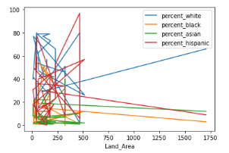

1. Median Age Vs State – This data is also from two different tables. This graph signifies the median age of the population in the city where the brewery exists against the state of the brewery. This gives an idea from the pattern.

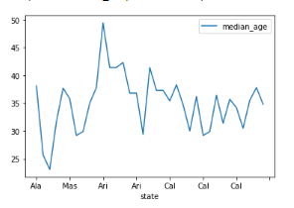

1. Total household Vs Population density – Again, data from two tables. This is a scatter plot, The total households in the city where the brewery is against the population density of the city. By seeing the plot, conclusions can be drawn.

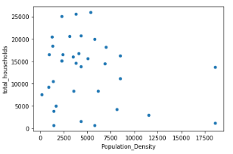

1. Per capita income histogram – Per capita income of the brewery city is displayed in the histogram.

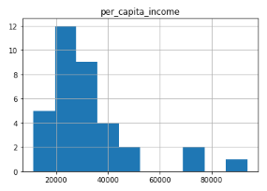

1. Population Bar chart – The population of the cities where the breweries are present. As per the chart, I do not see a particular pattern. Hence no conclusion can be drawn based on the population.

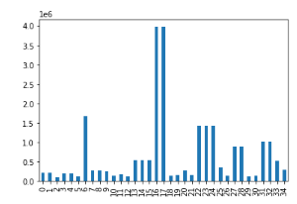

Based on the relationship of the three tables, tried to see the perspectives of different fields. I had a great experience and learned a lot.